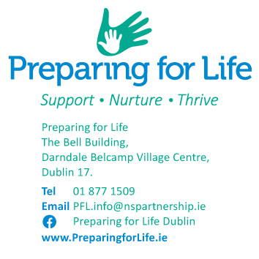

*Date*

Dear

**Re: Preparing for Life Programme**

I hope everything is going well for you and your family.  I’m writing to you because we have been unable to get in touch by phone/ text for the last three consecutive months.

As you will remember from our first meeting, we agreed that if we could not reach you for more than three months, we would assume that you had changed your mind about participating in the programme, and we would stop trying to contact you.

Because you have not been in contact with us, and we are currently unable to reach you, we assume that you no longer wish to participate in Preparing for Life.

If, however, you are still interested in participating in the Preparing for Life Home Visiting programme, please contact us as soon as possible, and we can meet up. Please let us know if you want to discuss working with a different team member.

I want to remind you that if your circumstances change in the future, you are welcome to rejoin the programme.

I wish you all the best for the future.

Kind regards,

________________________________

Home Visitor: XXX XXXXX

Direct line: XXXXXX

Mobile: 087 XXXXXXX