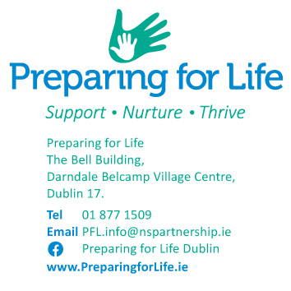

*Date xxxx*

Dear FAMILY NAME

**Re: Preparing for Life Programme**

I hope you and your family are keeping well.

I am writing to you again as I see from our records that it has been a long time since we visited. Unfortunately, I have not yet heard from you, and I assume you have changed your mind about participating in the Preparing for Life Home Visiting Programme.

If you are interested in picking up where we left off, please ring or call me at my number below.  We’d be delighted to welcome you back and guide you with your parenting.

If we don’t hear back from you in the next 4 weeks, we’ll understand that you no longer wish to be part of the programme and will end the disengagement process with a final letter and an exit form.

Our door is always open if things should change in the future.

Best wishes,

 

________________________________

Home Visitor: XXX XXXXX

Direct line: XXXXXXXX

Mobile: 087 XXXXXXX