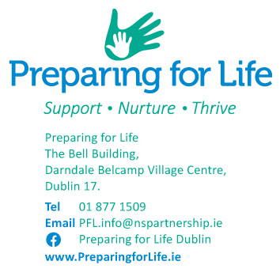

Insert date

Dear ,

I hope everything is going well for you and your family. I’m writing to you again because we remain unable to get in touch by phone and have not received a response from the letter sent to you on the date of letter 2.

As you will remember from our first meeting, we agreed that if we could not reach you for more than three consecutive months, we would assume that you had changed your mind about participating in the programme and stop trying to contact you.

Because you have not been in contact with us, and we are currently unable to reach you, we assume you no longer wish to participate in Preparing for Life. Considering this, we will now stop trying to contact you.

If you are still interested in participating in the Preparing for Life Home Visiting programme, please get in touch with us as soon as possible, and we can meet. Please let us know if you want to discuss working with a different team member.

I want to remind you that if your circumstances change, you are welcome to rejoin the programme.

I wish you all the best for the future.

Kind regards,

________________________________

Co-ordinator Eva Mills

Email: [eva.mills@nspartnership.ie](mailto:eva.mills@nspartnership.ie)

Mobile: 087 605 4488

Landeline : 01 877 15888