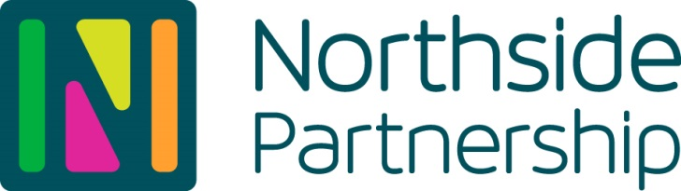

**Image Use Consent Form (Child/Dependent)**

This form deals specifically with the use of your child/dependent’s image to promote the work of Northside Partnership. With your permission, this form allows Northside Partnership to publish photos and recorded video images of your child in a variety of mediums as outlined below.

Northside Partnership commits to use these images with respect and only in a context relevant to your child’s connection with the services provided by Northside Partnership.

|  |  |
| --- | --- |
| **Child/Dependent’s Name:** |  |
| **Parent Name:** |  |
| **Parent Contact Number:** |  |
| **Parent Email:** |  |

**Please tick the boxes below to indicate your consent:**

|  |  |
| --- | --- |
| **□** | I give permission for my/my child/dependent’s photo / image to be published on [www.northsidepartnership.ie](http://www.northsidepartnership.ie)  www.preparingforlife.ie |
| **□** | I give permission for my/my child/dependent’s photo / image to be published on Northside Partnership social media sites – Facebook, Twitter, Instagram, LinkedIn |
| **□** | I give permission for my/my child/dependent’s photo / image to be used in printed format promotional materials and reports for funders. |
| **□** | I give permission for my/my child/dependent’s photo / image to be used in video format promotional materials for funders. |
| **□** | I give permission for my/my child/dependent’s photo / image to be provided to journalists for feature pieces on the work of Northside Partnership. |

**Signed: Date:**